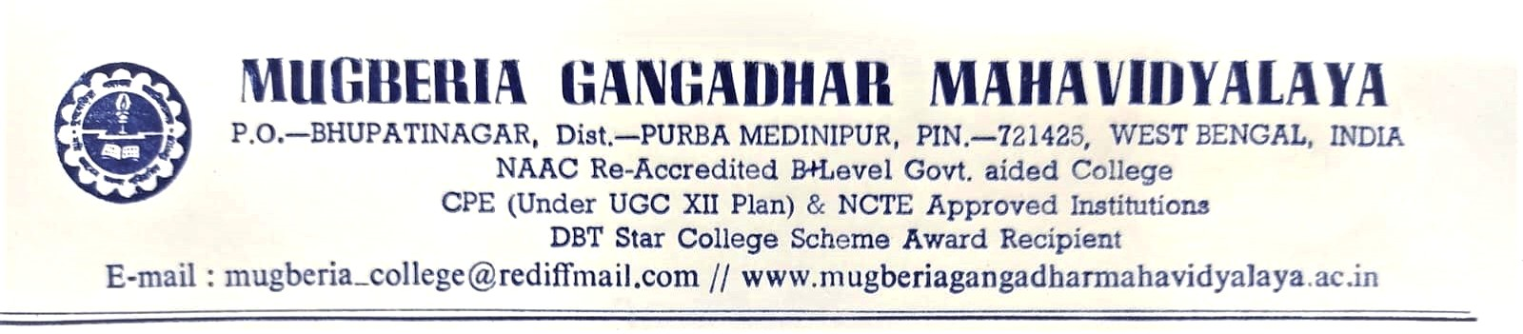

Report on Ramanujan Memorial Lecture during 2018 to 2023

