REPORT FOR FREE ONE DAY WOMEN'S SELF DEFENCE TRAINING

A one day women self defence training camp was organised in Mugberia Gangadhar Mahavidyalaya by Martial Arts Organisation of India on 24th April, 2020. In this training camp around 80 female students and Teachers took self defence training of different defence techniques under the supervision of Sihan Arup Das, founder and General Secretary of MAOI.

The training camp started at 10 a.m. by inauguration address by our Principal Sir Dr. Swapan K Misra and chief instructor of the training camp Sihan Arup Das in S N Bose seminar hall.
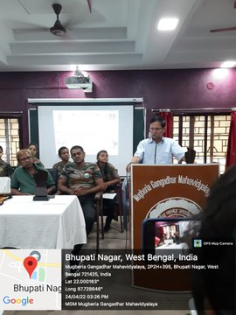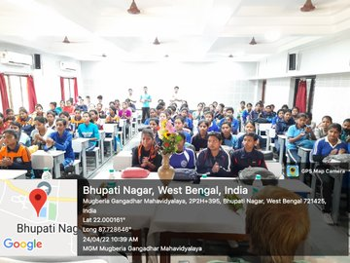

Then participants were taken to Satabdi Sadan were they practiced several self defense techniques demonstrated by Sihan Arup Das and his team.

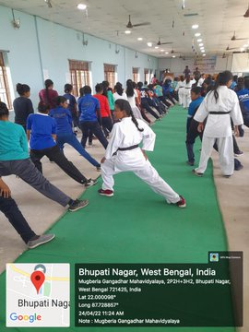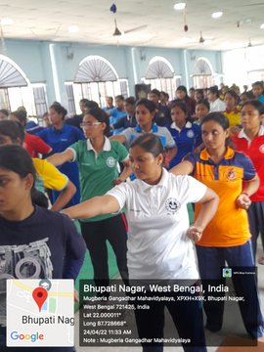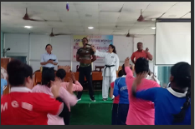

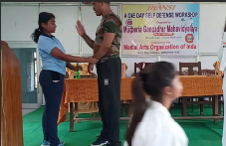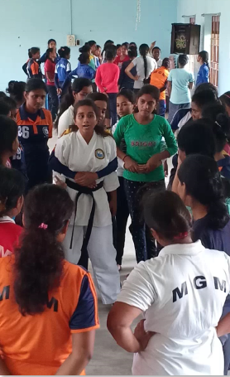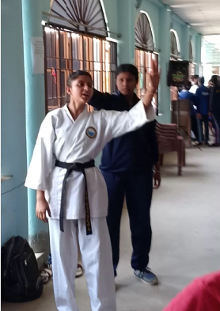

Then participants were given lunch break from 1:30 to 2 p.m. 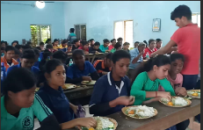
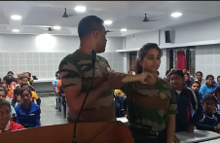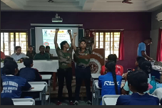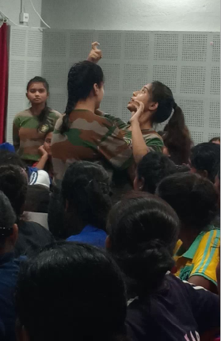

After this break participants were again brought to S.N. Bose seminar hall where a psychological awareness was conducted by the trainers for several hours to boost the self confidence of the participants.

At the end feedback was taken from several participants and also from our present faculties like HOD Physical Education Dr. Debashish Ray, HOD Philosophy Sri Subhash Chandra.

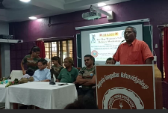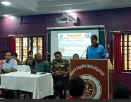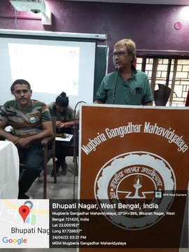

Sihan Arup Das and his Team members were felicitated with memento and letter of appreciation for their contribution.
Participants were also given certificates for participating in this training camp

