Faculty Development Program
O
n an
d

F
rom 20
/
0
/
6
27
to
2022
/
0
/
6
2022
Under
DBT STAR COLLEGE STRENGTHENING
SCHEME, GOVT. OF INDIA
Organized by Department of Chemistry, Zoology and Mathematics,
Mugberia Gangadhar Mahavidyalaya, Bhupatinagar, Purba Medinipur,
West Bengal, India.
Course Design
Area:
CAS, IPR, Teaching Learning,
Innovative Research, Software,
Span o
f
t
h
e
_{Program}
₇
_{days}
Time:
1.15

m to 3.15
Environment
Number of Topics:
7
on both
Theoretical and Practical aspects
p
pm (Monday –Friday)
_{Saturday: 12.15‐2.15 pm}
❖
Course Fee:
No course fee will be charged

PARTICIPANTS: Faculty members Mode of Program including Librarians, Research Scholars OFF-LINE and PG students
Resource Persons, Theme of presentation & Tentative Dates
1. | Dr. Shyamal Kumar Mondal, Professor, Dept. of Applied Mathematics with Oceanology and Computer Programming, Vidyasagar University. Theme: Software, 20/06/22
2. | Dr Pritha Bhattacharjee, Asst. Prof. Department of Environmental Science, University of  Calcutta. Theme: Environmental Research, 21/06/22
3. | Dr. Pijush Kanti Tripathi, Officer-in-Charge, Haldia Government College, Theme: CAS,  22/06/22
4. | Apurba Kumar Chatterjee, Technical Manager, Good Earth Enviro Care, Narendrapur,  Kolkata. Theme: Environmental Pollution Monitoring, Management & Research, 23/06/22
5. | Prof. (Dr.) Pradipta Kumar Mishra, Principal, Yogoda Satsanga Palpara Mahavidyalaya.  Topic: An Effective Teacher in Higher Education for 21st Century, 24/06/22
6. | Sri Amiya Kumar Kalidaha, Senior Scientific Officer, Department of Science and  Technology & Biotechnology, GoWB, Kolkata. Theme: IPR, 25/06/22
7. | Prof. (Dr.) Nandan Bhattacharyya, Principal, Panskura Banamali College, Theme:  Innovative Research ideas, 27/06/22
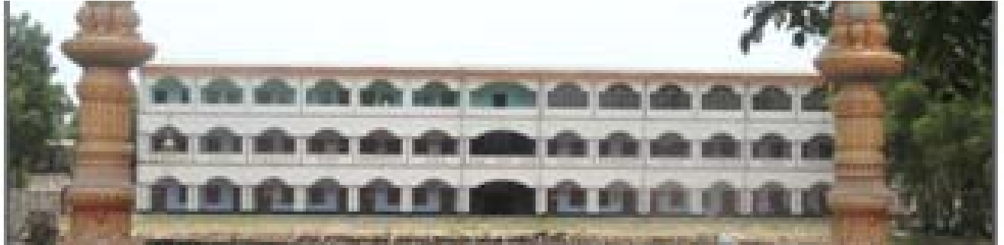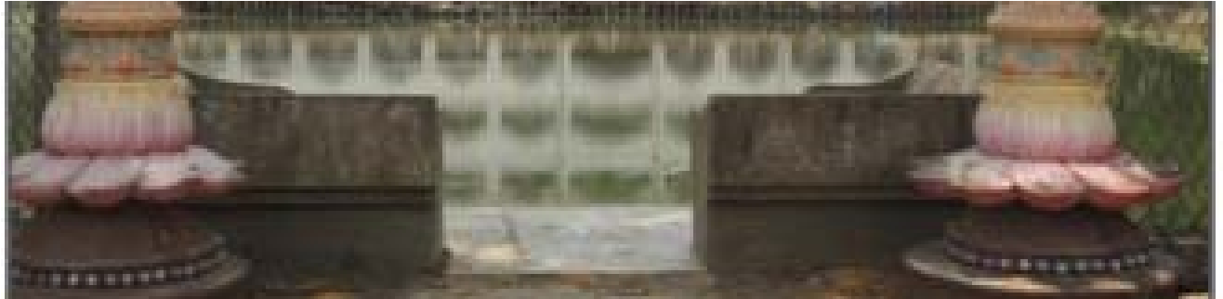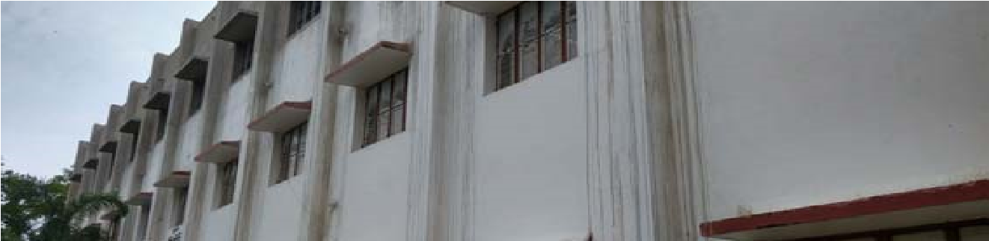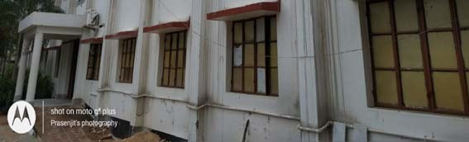
Organizing Committee
❖
Chairperson:

Dr

Swapan

Kumar

Misra,

Principal, Mugberia Gangadhar
Mahavidyalaya
❖
Program Co-ordinator:
Dr Bidhan
Chandra Samanta, Associate Professor,
De
t of Chemistr
and Co-ordinator, DBT
p
y
Star College Scheme
❖
Jt Co-ordinator:
Dr Kalipada Maity,
A
ssoc
i
ate Pro
f
essor & HOD, Dept o
f

Mathematics
❖
Contact Email:
bidhansamanta@yahoo.in
;
kmaity78@gmail.com
All are cordially invited

