Report
On

Sexual Harassment of Women at Workplace (Prevention, Prohibition and Redressal) Act, 2013
Organized by
Women’s Cell
Mugberia Gangadhar Mahavidyalaya

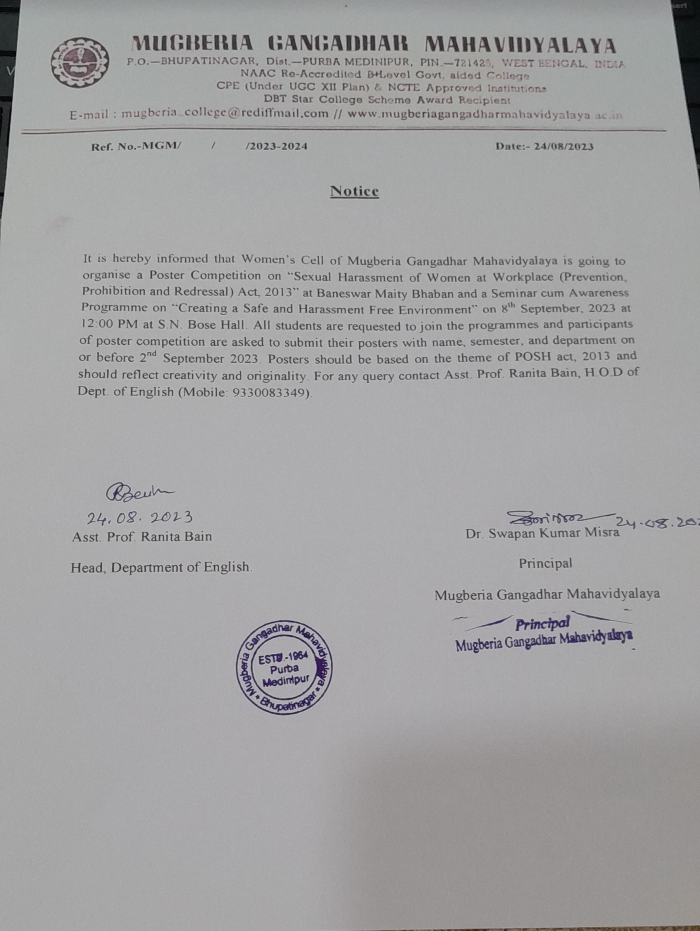

Members present:
1. Dr. Swapan Kumar Misra, Principal, MGM.
2. Prof. Jonaki Biswas HOD & Associate Prof., Dept. of Political Science, Coordinator, Women’s Cell.
3. Prof. Ranita Bain, HOD & Assistance Prof., Dept. of English
3. Prof. Taniya Niyogi, Assistance Prof., Dept. of English
4. Ms. Sobha Sahoo, SACT Dept of English
5. Ms. Sobha Sahoo, Office Staff
6. Prof. Irani Chatterjee, HOD & Assistance Prof., Dept. of Geography
7. Prof. Sutapa Saha, HOD & Associate Prof., Dept. of Political Science
8. Prof. Prasenjit Ghosh, HOD & Associate Prof., Dept. of History, IQAC Coordinator.
9. Ms. Deblina Acharyya, SACT, Dept of English

A short meeting was held on 24th August 2023, at 3 pm on how to spread awareness regarding Sexual Harassment of Women at Workplace (Prevention, Prohibition and Redressal) Act, 2013. All the above members and the Principal of the college were present in the said meeting. It was chaired by the Principal of the college.
Following decisions were taken in the meeting:
- It is decided that a poster competition will be held among all the students on the theme of POSH Act, 2013.
- The winners of the competition will be awarded.
- A Seminar will be held on POSH Act, 2013.
- Prof. Poulomi Mukherjee, HOD & Assistance Prof., Dept. of Education, Khejuri College, will be invited as the resource person and keynote speaker for the seminar.
- The poster competition and seminar will be held on 8th September.

The meeting comes to an end with a vote of thanks.
FLYER OF THE POSTER COMPETITION ON POSH ACT,2013

Images of the Poster Competition on POSH Act, 2013

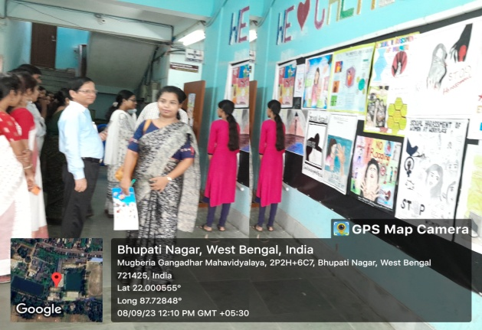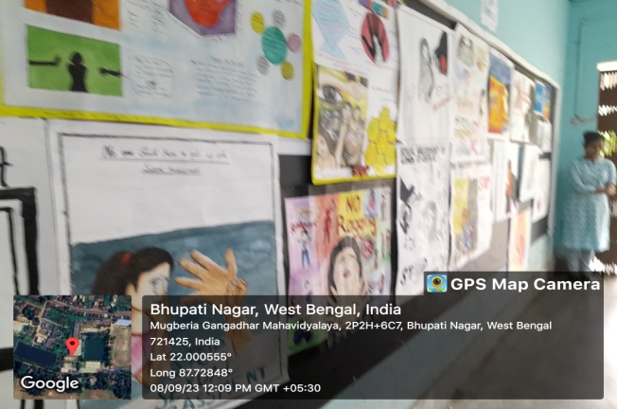

SIGNATURE OF POSTER-COMPITITION-PARTICIPANT STUDENTS

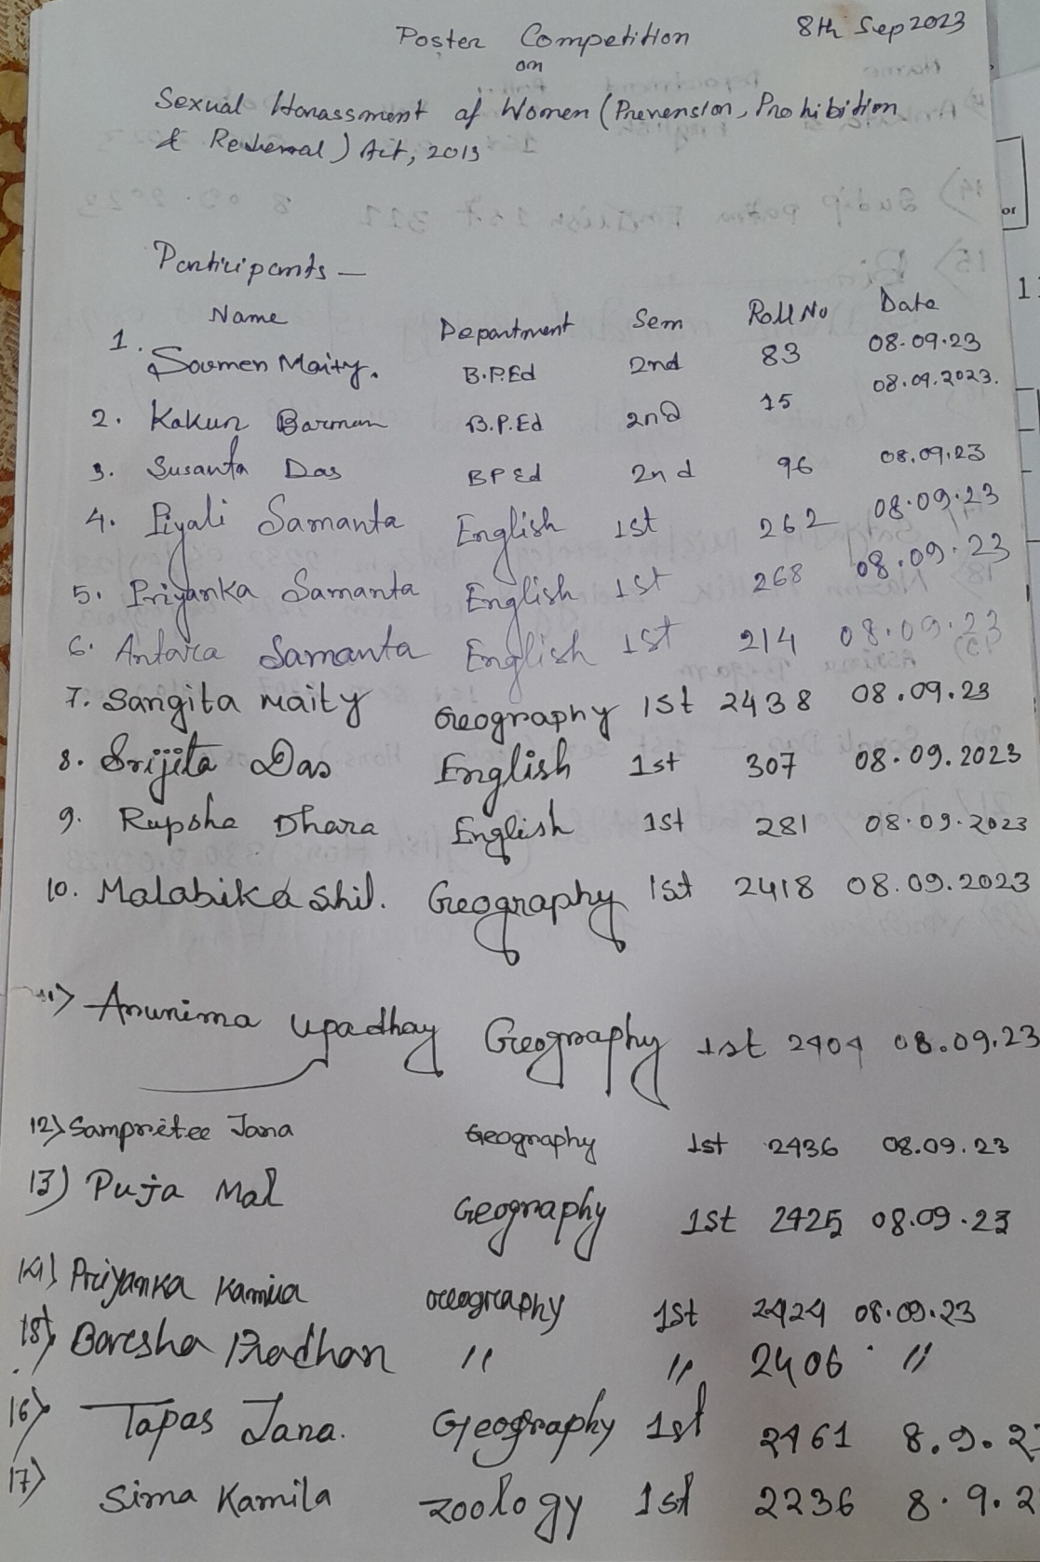
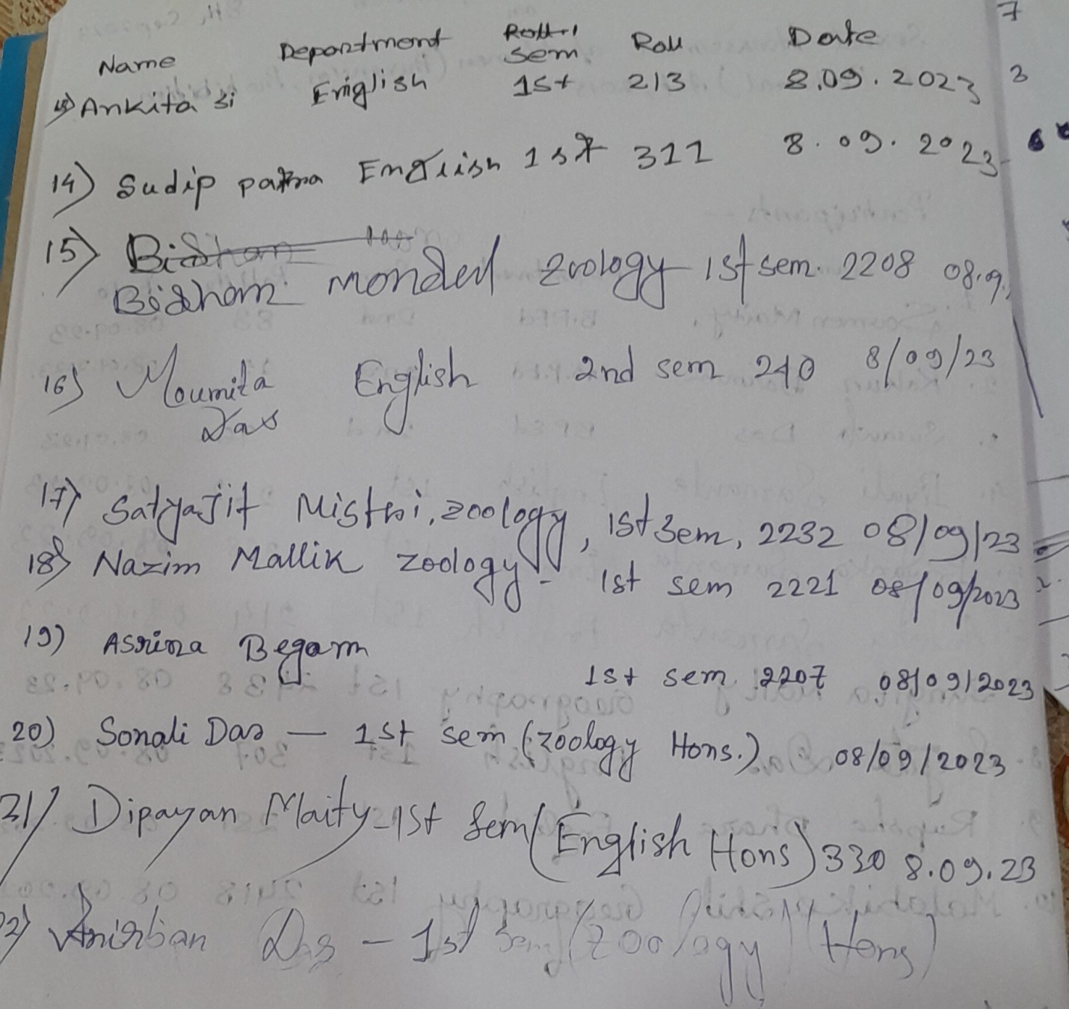

SIGNATURE OF POSTER-COMPITITION JUDGES

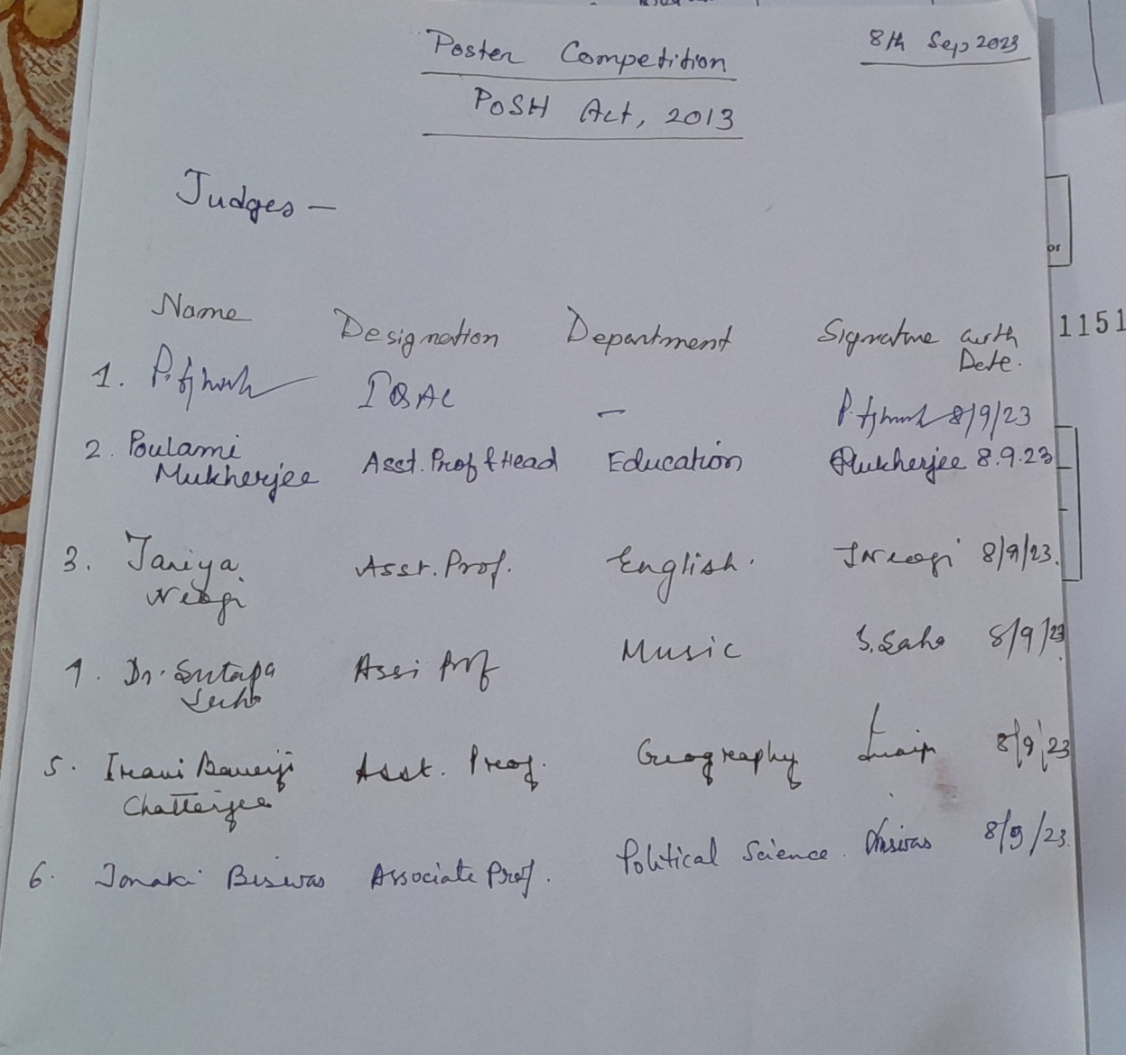

Twiter link of the poster presentation program on POSH-
https://x.com/MugberiaM/status/1700152997542519119?t=TAwHBkDaq7YPdITN32TSIg&s=08

FLYER OF THE SEMINAR ON POSH ACT, 2013

Images of the Seminar on POSH Act, 2013

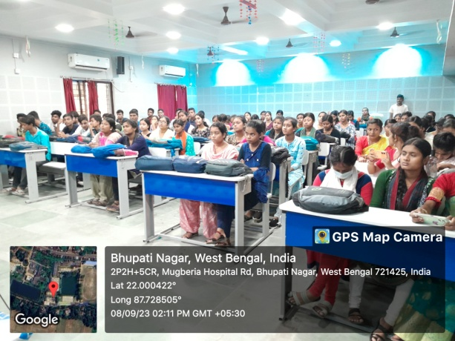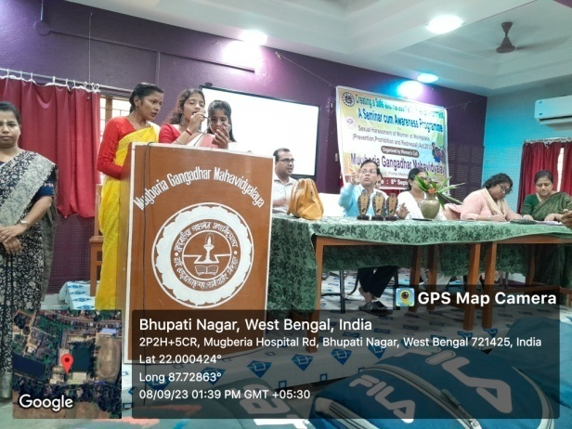

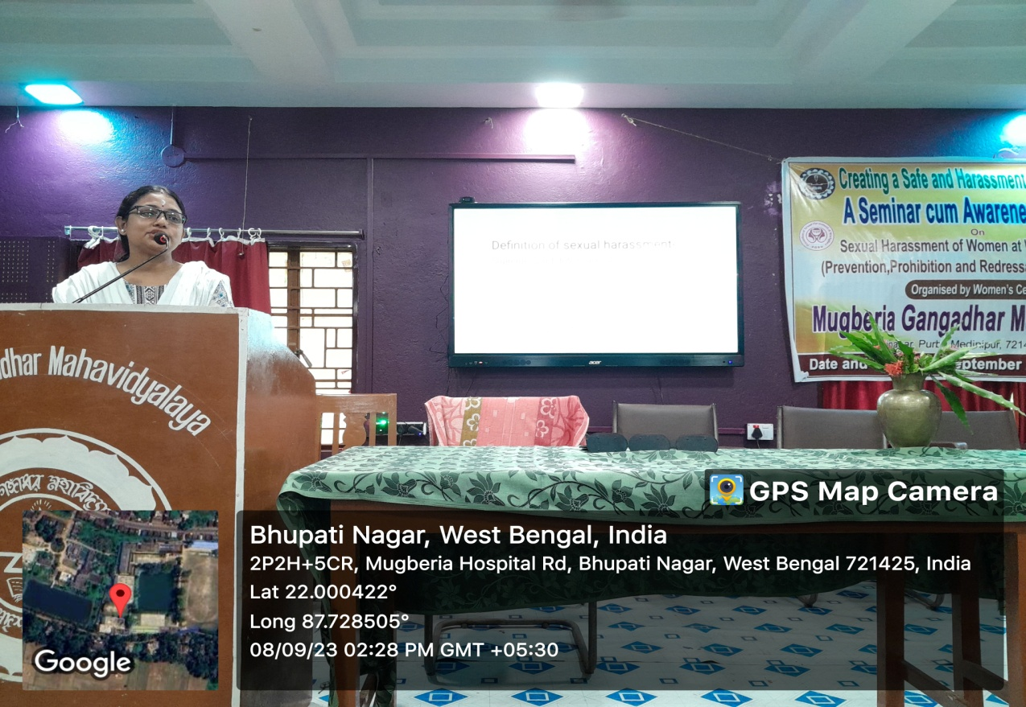

IMAGE OF THE INVITATION LETTER TO THE RESOURCE PERSON

IMAGE OF LETTER OF APPRECIATION

OBJECTIVES THE POSH AWARENESS CAMPAIGN:
Firstly, it was advised by the UGC to conduct POSH awareness campaigns. In addition, just having a law does not help. Many a times, women question whether a particular behavior can be counted as sexual harassment even after they felt uncomfortable or violated. So, it is important for employees as well as students to know what is acceptable in the workplace or educational institutions and what constitutes to sexual harassment and what does not.
Moreover, the employees and students should also be aware about what to do if their colleagues or classmates are subjected to sexual harassment. An effective aware on POSH can address these issues. Organizing POSH training is a step towards protecting the rights of women employees and ensuring equality at the workplace. All the employees as well as students must participate in this awareness programs regardless of their gender or designation.

VENUE OF THE PROGRAMMES:
S. N. Bose Hall
Baneswar Maity Bhaban
Mugberia Gangadhar Mahavidyalaya

CO-ORDINATORS OF THE PROGRAMMES:
Prof. Ranita Bain, HoD & Assistant Professor, Department of English
Prof Jonaki Biswas, HoD & Associate Professor, Department of Political Science

Twitter link of the Seminar on POSH –
https://x.com/MugberiaM/status/1700155575701561447?t=_NoYbRJsgfLhRMY96Ud06A&s=08

STUDENTS PARTICIPATION:
SIGNATURE OF THE STUDENTS WHO WERE PRESENT AT THE SEMINAR
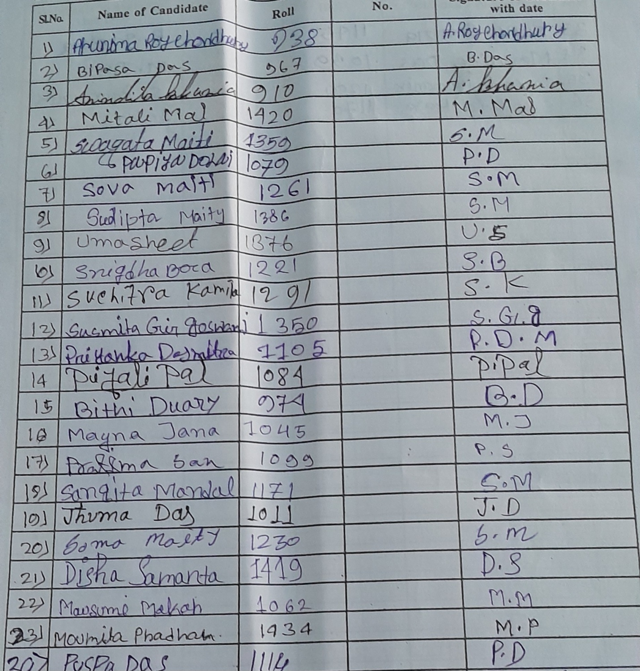
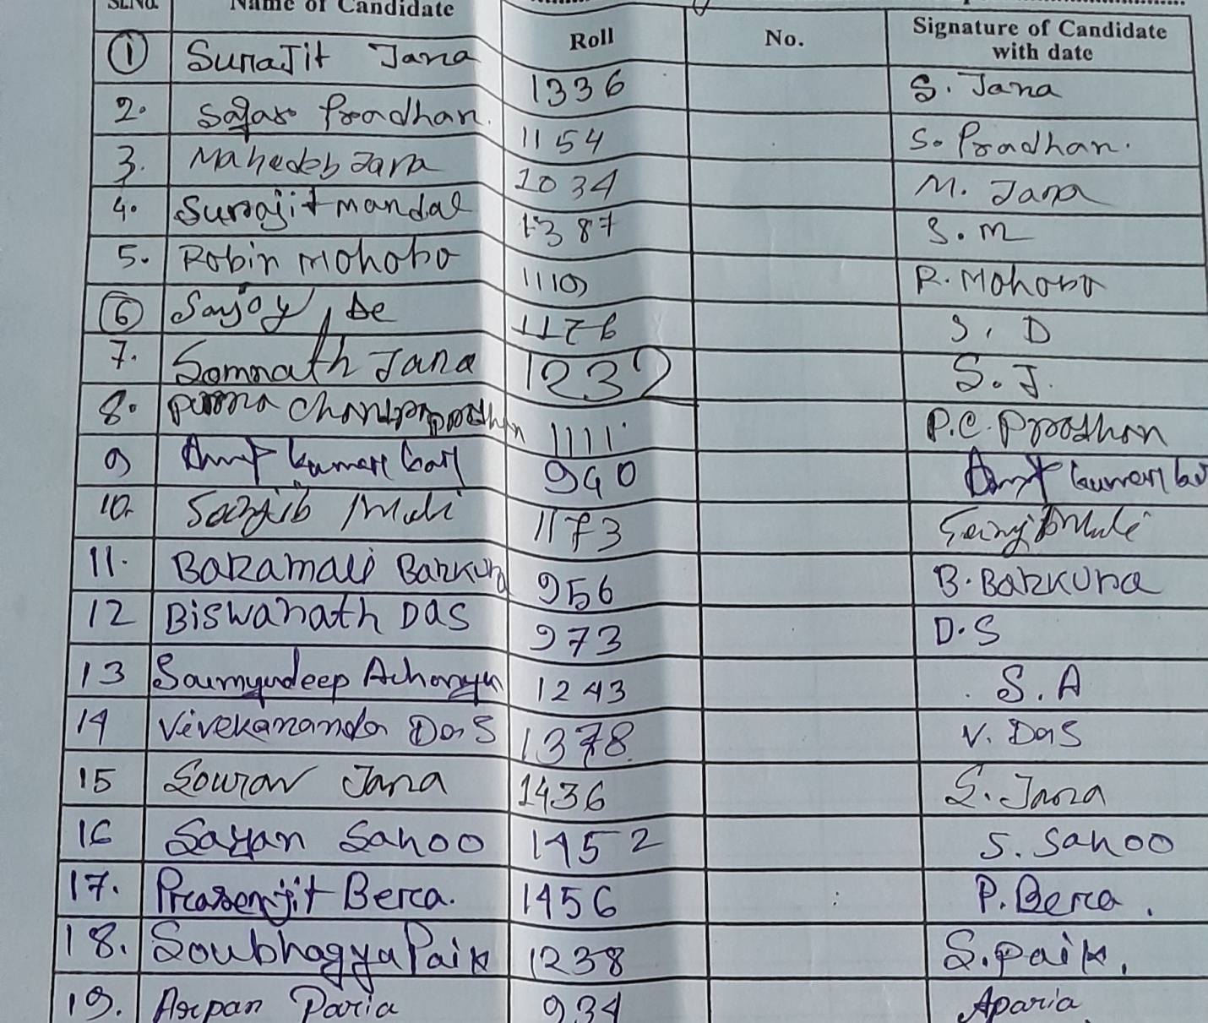
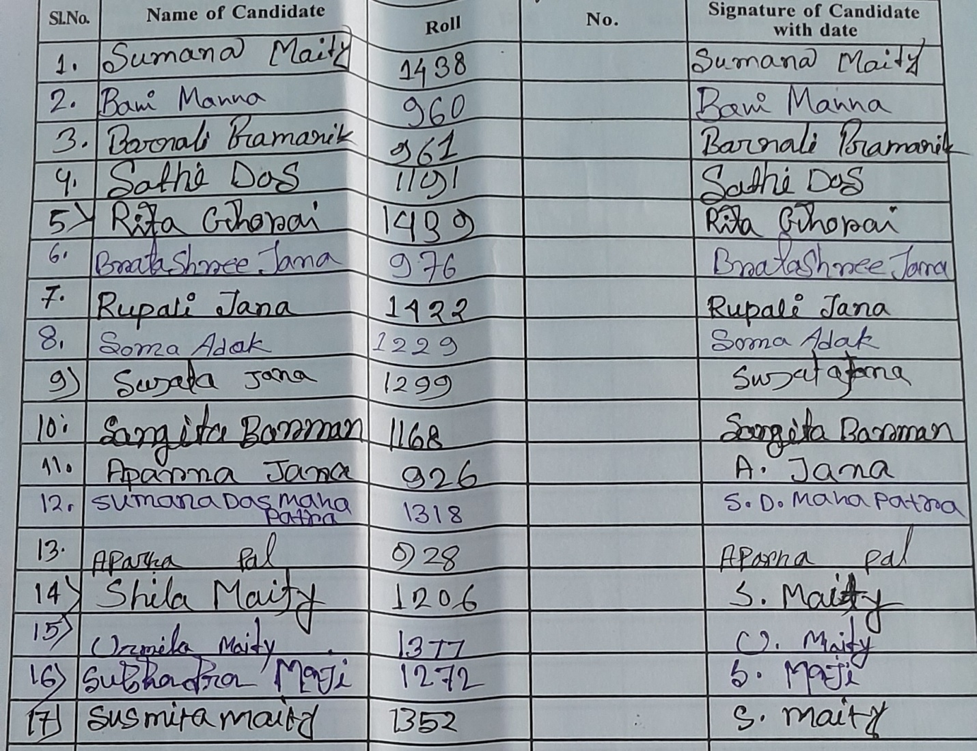
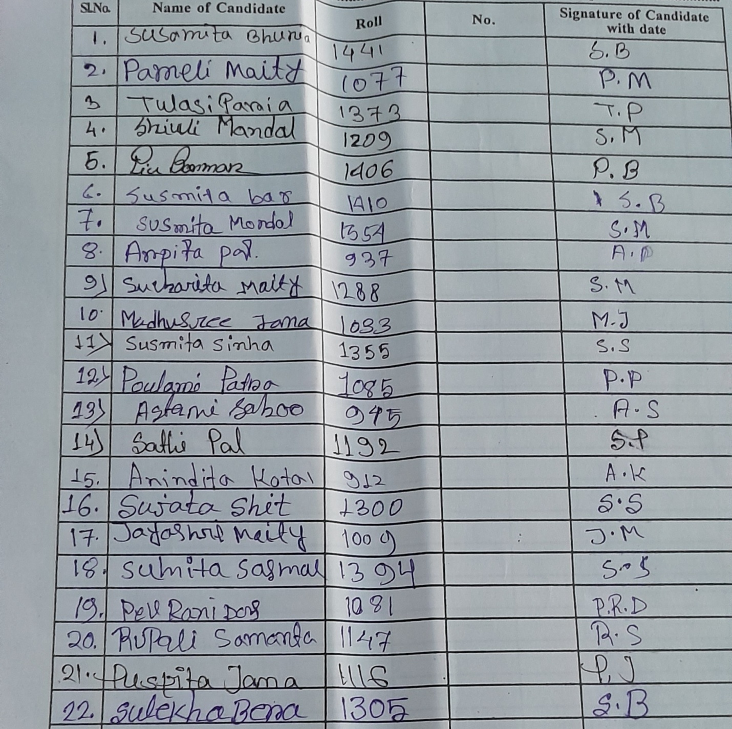
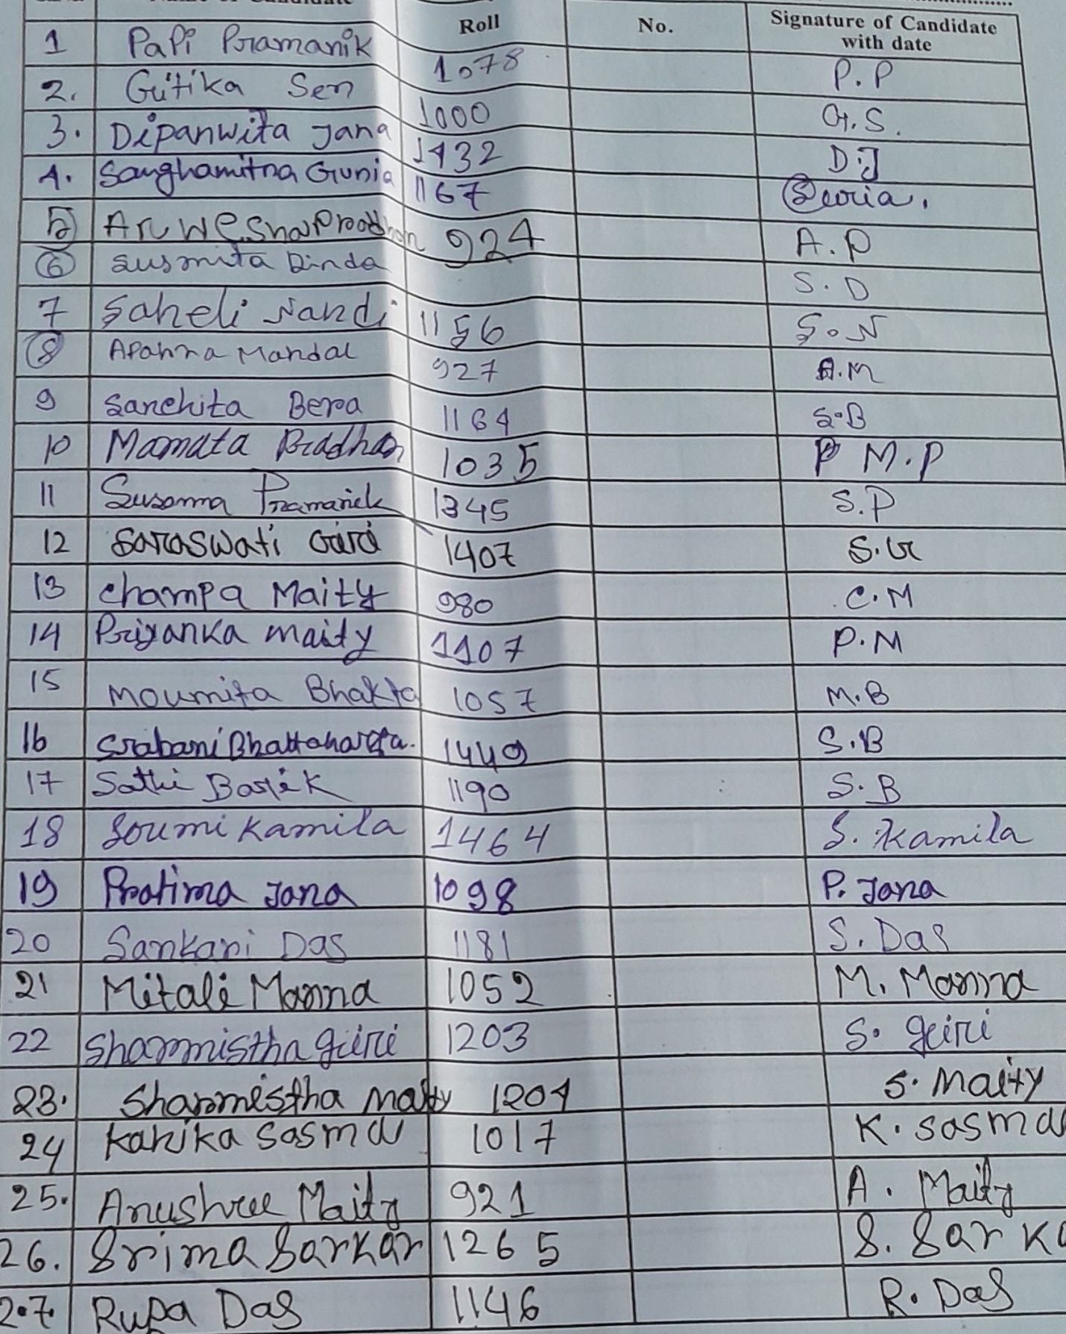
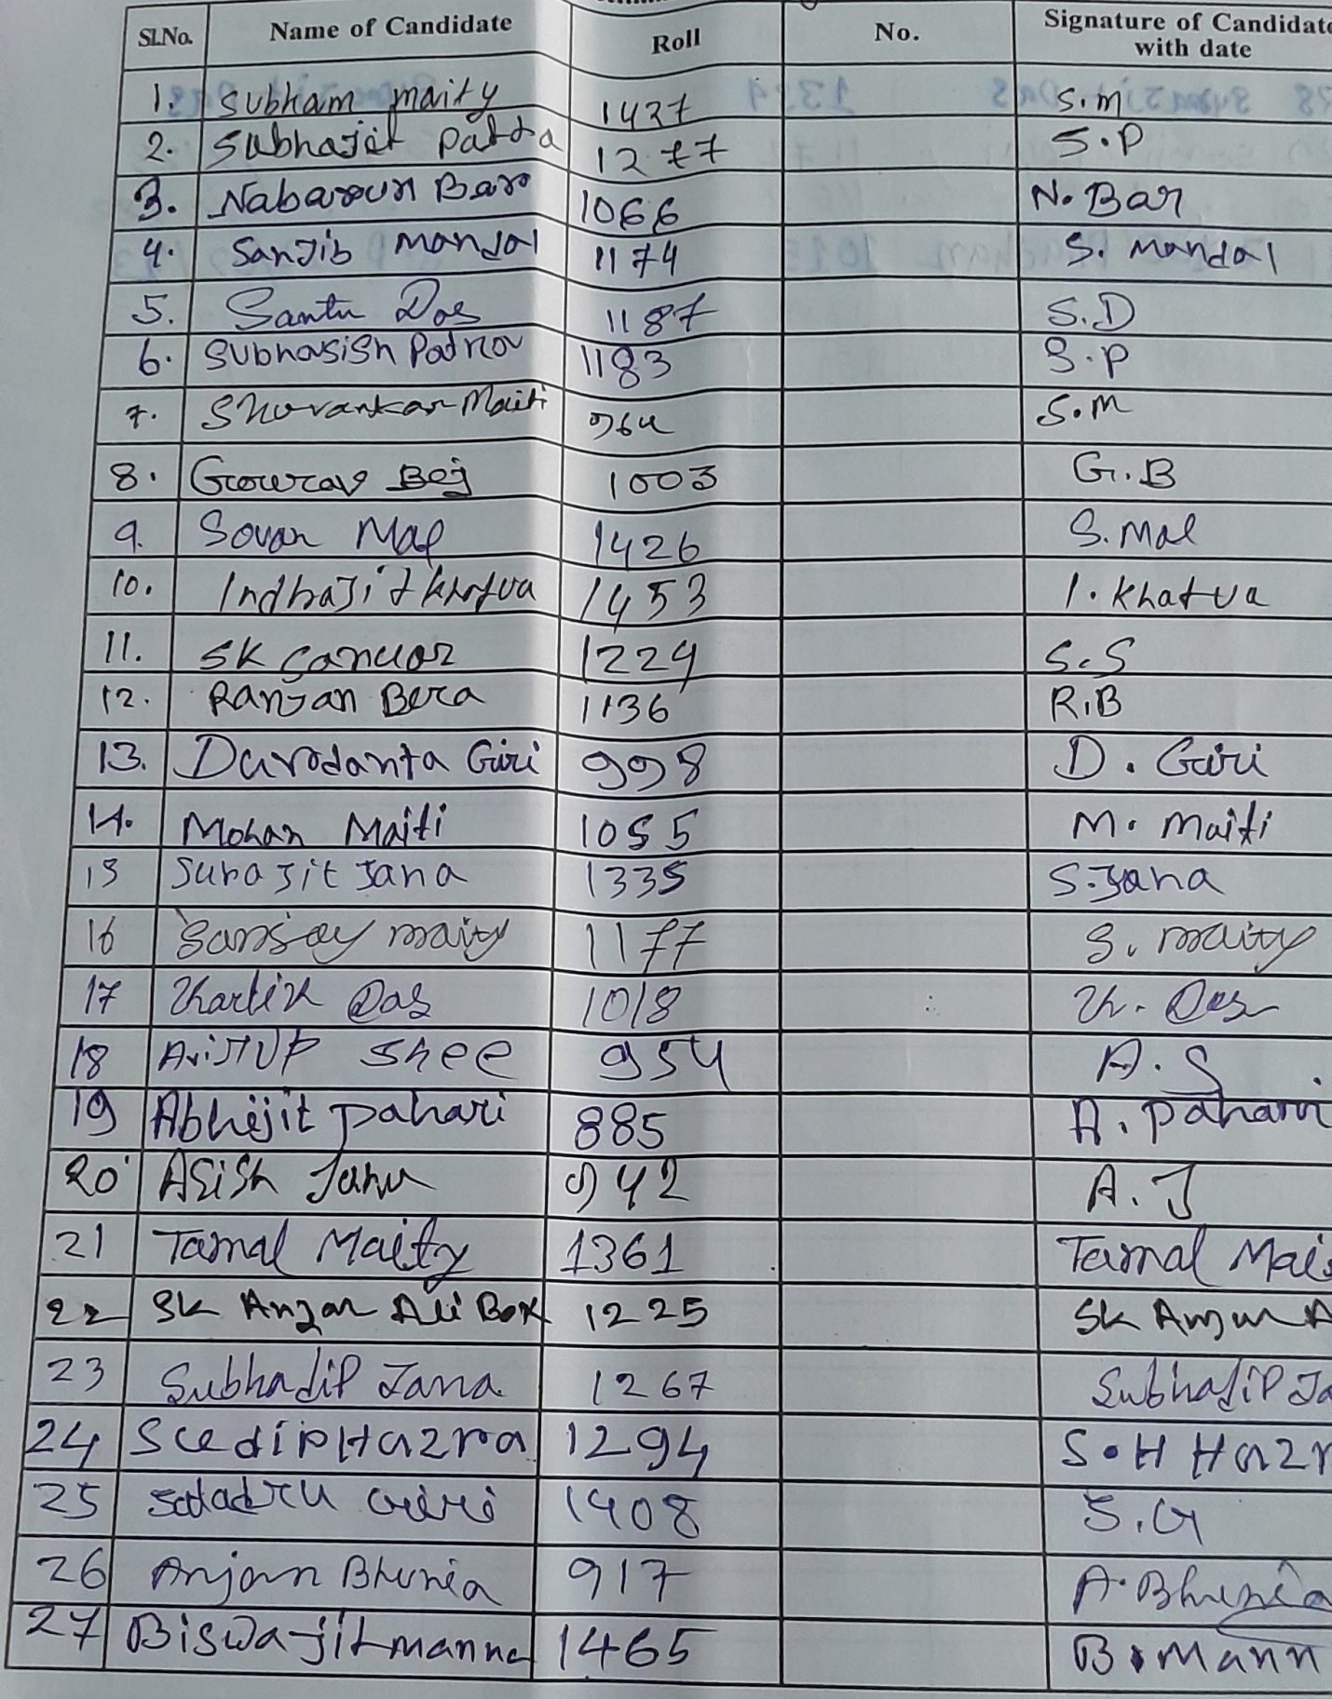

OUTCOMES OF POSH AWARENESS CAMPAIGN
The benefits of organizing POSH awareness campaigns in our college are as follows-
- Sexual harassment can hamper productivity of not only the victims, but also other employees and students. Better the campaign, lesser the incidents of sexual harassment and higher the productivity.
- POSH awareness campaign shows that the college cares about the employees and students which can increase job satisfaction and students’ engagement.
- POSH campaign improves students’ retention and the quality of education. The campaign improves the perception of employees and students about the college.
- The reputation and goodwill of the college can be damaged if employees and students decide to reveal their horrible experiences of sexual harassment via social media. The college may lose its students as well. Sensitizing the employees and students through POSH campaigns and programs can safeguard the organization’s reputation and ensure student retention.
- Like mentioned before, non-compliance to the act can attract penalties. There can also be chances that the legal fight can take a long time which will result in a huge financial impact. Conducting regular POSH training and awareness programs will not only help in avoiding such legal tangles but can also act as a proof in the court that the college had taken necessary steps for prevention of unfortunate sexual harassment incidents.

