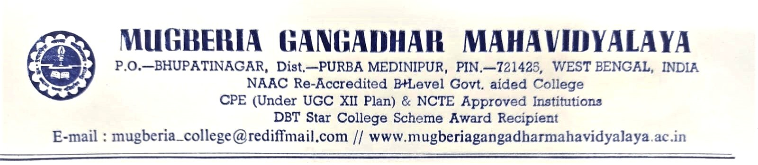

Report
on
Teacher Exchange Program
Organized by
Department of English
Khejuri College

In collaboration with
Department of English
Mugberia Gangadhar Mahavidyalaya,

Teacher Exchange Programme
Department of English, Khejuri College organized a Teacher Exchange Program on 27 May 2022. Accordingly, Prof. Ranita Bain, Assistant Professor, Department of English, Mugberia Gangadhar Mahavidyalaya, went to Khejuri College to share her knowledge and experience with the students and teachers of Khejuri College. Mugberia Gangadhar Mahavidyalaya already signed a MoU with Khejuri College. This Teacher Exchange Program is part of it.
Prof. Ranita Bain presented a paper, Configuring Restoration Plays: A Search for its Diversity, in front of students and teachers of various department and interacted with them.

Students’ Participation
Department of English, Khejuri College organised a Teacher Exchange Program on 27 May 2022. Accordingly, Prof. Ranita Bain, Assistant Professor, Department of English, Mugberia Gangadhar Mahavidyalaya, went to Khejuri College to share her knowledge and experience with the students and teachers of Khejuri College. Mugberia Gangadhar Mahavidyalaya already signed a MoU with Khejuri College. This Teacher Exchange Program is part of it.
Prof. Ranita Bain presented a paper , Configuring Restoration Plays: A Search for its Diversity, in front of students and teachers of various department and interacted with them.

Outcome
This event provided a platform for students and teachers of the department of English, Khejuri College to know the pedagogical practices of Mugberia Gangadhar Mahavidyalaya. Such programs are enriching both for teachers and students.
Letter of Appreciation
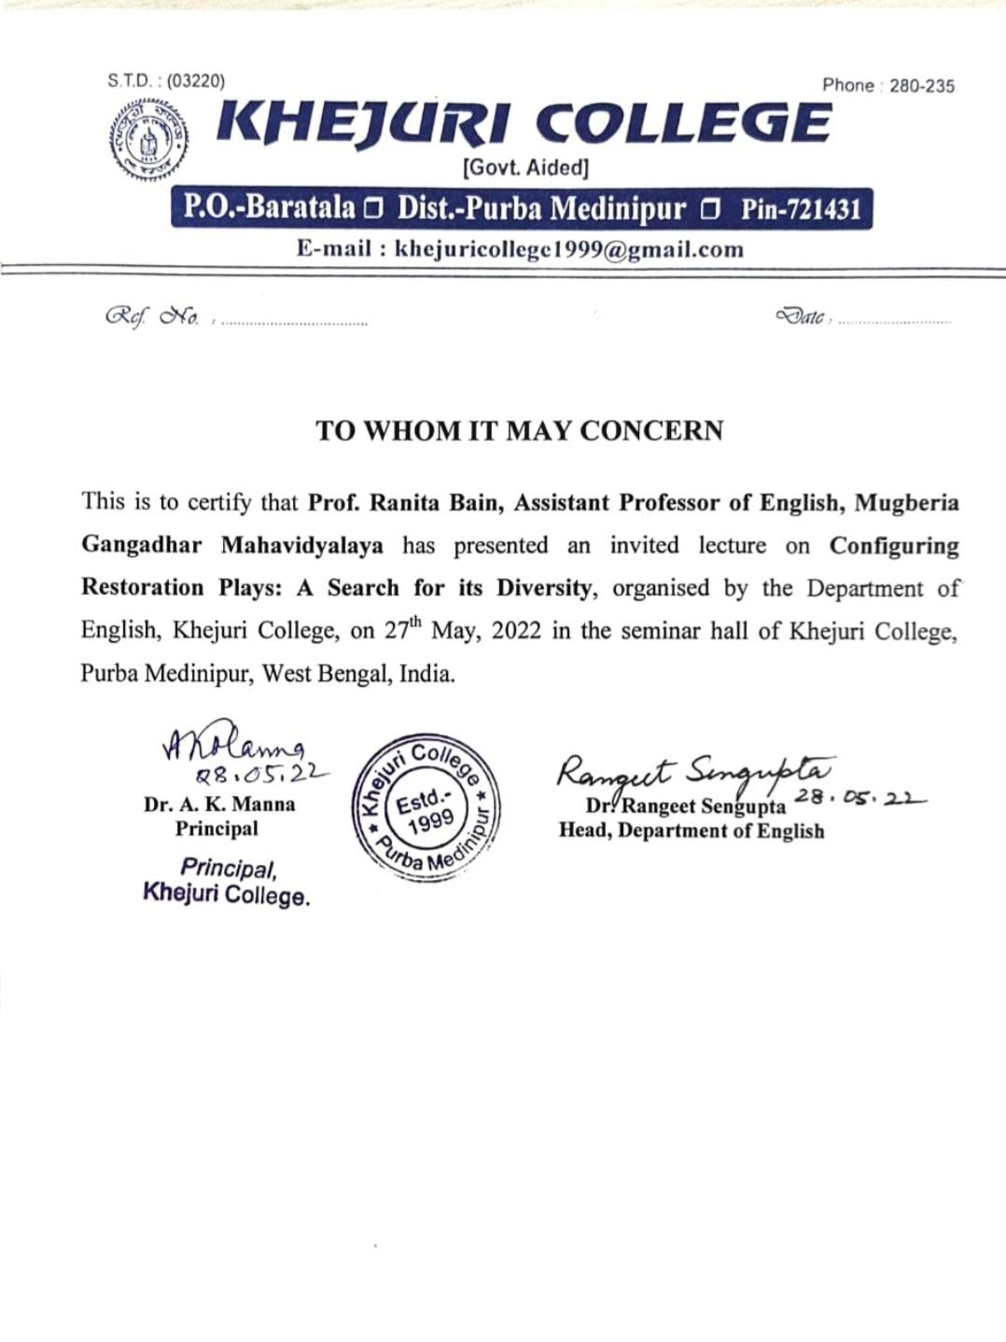

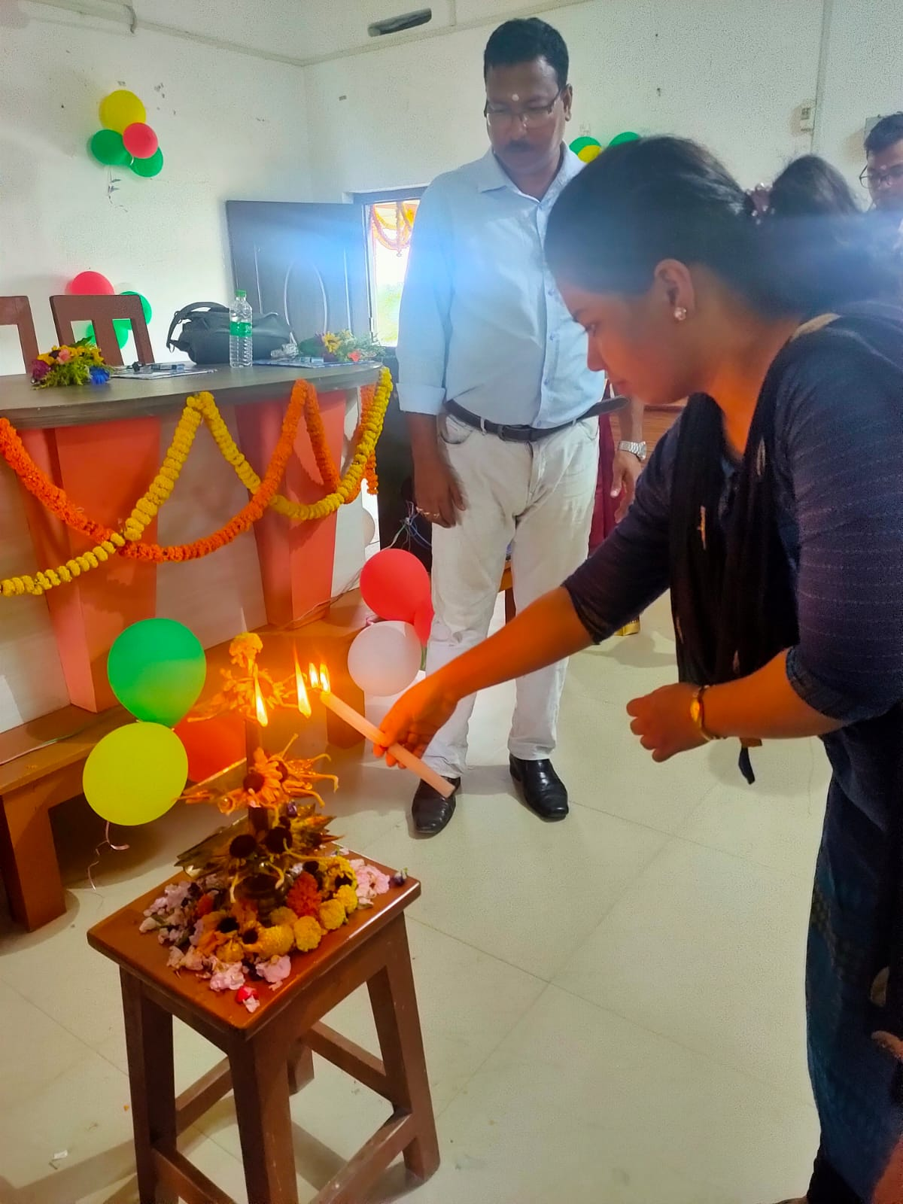
Prof. Ranita Bain inaugurating the program

